Module 8.1 - Milestone #1
Group Name: Team A
Group Members: Brittany Smith, Arrington Capehart, Armond Byford
Case Study: Outland Adventures

Business Rules:
1. A customer can book one or more trips.
2. A trip can have one or more customers.
3. Each trip takes place at one location.
4. A location can have multiple trips.
5. Outland Adventures can offer trips in multiple locations.
6. A customer can purchase equipment from Outland Adventures.
7. A customer can rent equipment from Outland Adventures.
8. Equipment can be rented or purchased by customers.
9. Each equipment item has a purchase date so the age of the equipment can be determined.
10. Employees have specific jobs or responsibilities within the company.
11. Guides are responsible for organizing and planning trips.

Assumptions:
1. Each customer has a unique customer ID.
2. Each trip has a unique trip ID.
3. Each location has a unique location ID.
4. Each equipment item has a unique equipment ID.
5. A trip can have multiple customers; the many-to-many relationship between CUSTOMER and TRIP is resolved through BOOKING.
6. Equipment inventory records include the date the equipment was purchased.
7. A customer can have multiple equipment transactions.
8. Equipment transactions include the transaction date and whether the equipment was rented or purchased.
9. Africa, Asia, and Southern Europe are treated as separate locations or regions in the database.
10. Booking dates and equipment transaction dates will be stored so reports and trends can be analyzed over time.
11. Outland Adventures maintains an inventory of its equipment.
12. Trip bookings are recorded with a booking date so the company can compare booking activity by location over time.
13. Equipment transactions are recorded so the company can compare equipment rentals versus purchases.

Initial ERD:
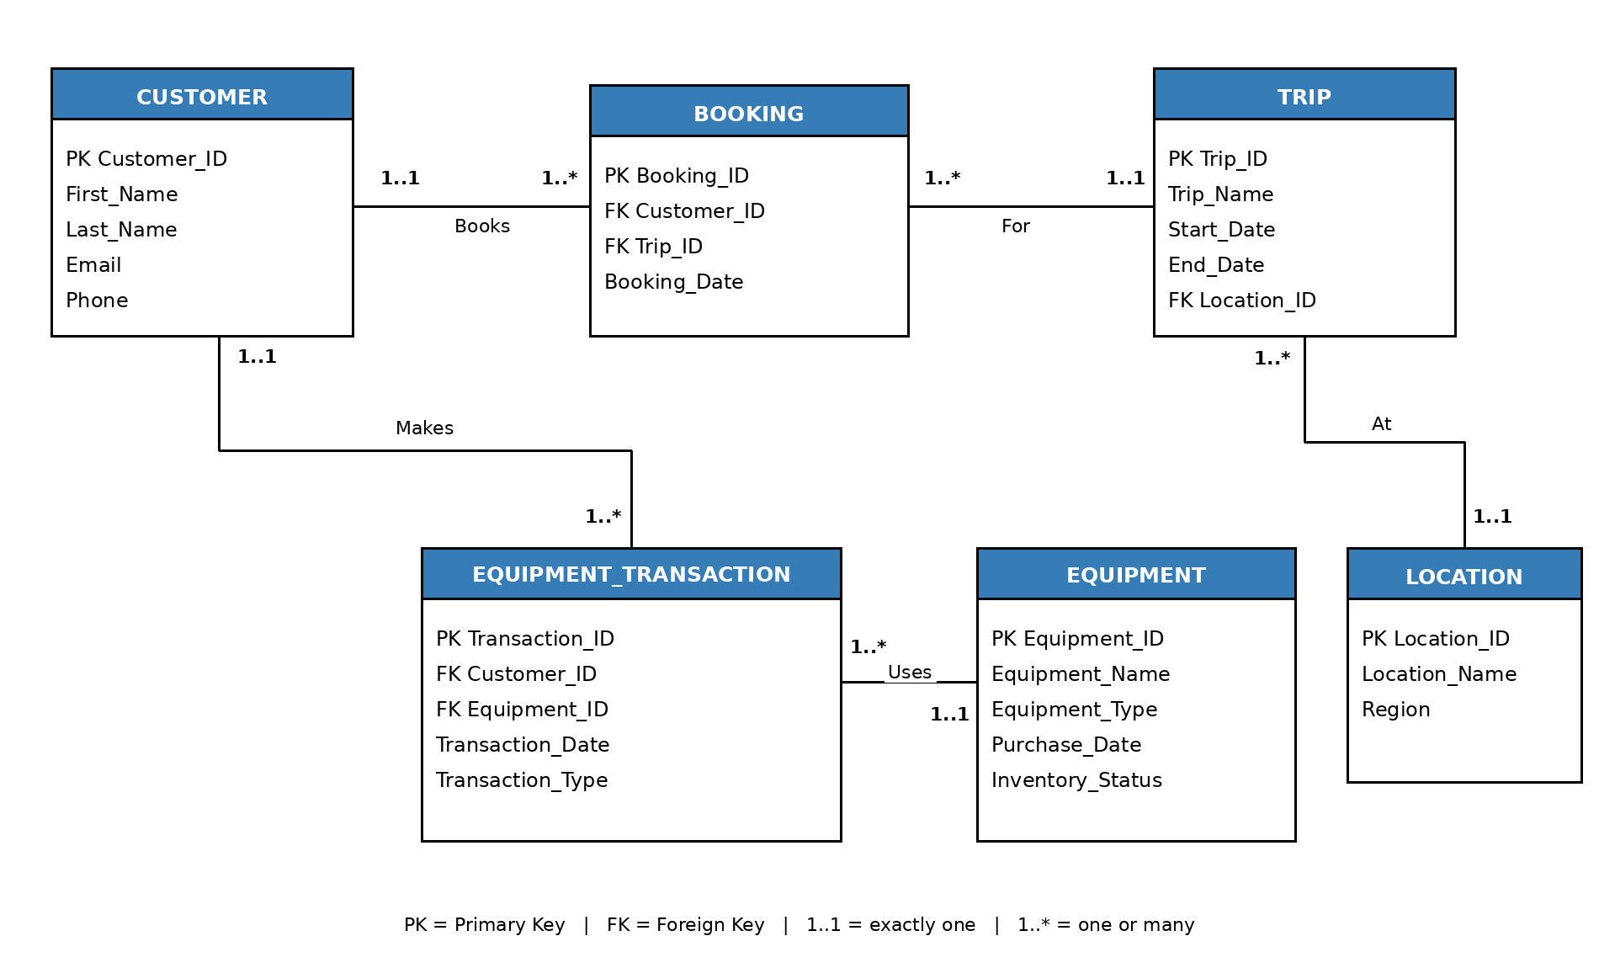
Relationship summary:
- CUSTOMER 1..1 to BOOKING 1..* - one customer can have multiple bookings; each booking belongs to one customer.
- TRIP 1..1 to BOOKING 1..* - one trip can have multiple bookings; each booking is for one trip.
- LOCATION 1..1 to TRIP 1..* - one location can host multiple trips; each trip occurs at one location.
- CUSTOMER 1..1 to EQUIPMENT_TRANSACTION 1..* - one customer can have multiple rental or purchase transactions.
- EQUIPMENT 1..1 to EQUIPMENT_TRANSACTION 1..* - one equipment item can appear in multiple transactions over time.

